FOUNDATION FOR VIRTUAL AND AUGMENTED REALITY SYSTEMS
Lecture34
Lec-34: Introduction to Majuli case study
Welcome to the NPTEL MOOCs course on Foundations for Virtual and Augmented Reality Systems. We are now discussing the use case, and we will be continuing our discussion and covering the other aspects of the use case in this part of the lecture. So, earlier we talked about the basics of the use case, that is, what it is all about and why we need to do it. Now, in this part of the lecture, we are going to talk about what the key concerns and issues are that we should address while trying to build the system. Let us talk about the key concerns.
So, the major or broader objective is to capture the tangible and intangible aspects of the island's cultural heritage. So, here our focus will be mostly on cultural heritage. Sites, ecological heritage has similar issues and challenges. So, we will not separately mention them; rather, we will be trying to explain things in terms of cultural heritage. So, this is one of the major issues: how to capture both the tangible and intangible aspects of cultural heritage in our proposed system.
Another issue is the user experience. The extent of presence experienced by the users during their interaction with the Majuli Island VR Tour. So, we are proposing to have an immersive VR experience to expose the users to the heritage aspects of Majuli. Now, the user experience side is also a major issue.
To what extent do users feel present in the virtual island? Third, but not least, is the issue of cyber sickness. So, here one of our key concerns should be how to minimize the risk of cyber sickness while the users are exploring the island. So, later on we will see why cyber sickness is an important issue in this context, in this particular use case. Now let us first talk about content preservation.
So, we said that our digital heritage preservation system has two components. One is preservation; the other one is experiencing the heritage, that is, through immersive virtual tours. So, let us first have some idea on the preservation effort which leads to the content of the virtual tour. which allows users to explore the island virtually. Now, in order to understand the difficulty in preservation, we have to understand the expanse of information, what kind of expansive information we are dealing with.
We talked about distinct tribal cultures. that are part of the island. So now there are tribal villages that dot the landscape. So whenever we need to create a virtual tour of the island, we need to be aware of the tribal villages and their uniqueness while trying to recreate that experience. Preserving unique traditions and customs passed down through generations is characteristic of such villages, and we should be able to reproduce that in our virtual tour.
Now we talked about three major tribes: Mishing, Deori, and Sonowal Kacharis. They are of course among the more indigenous, more prominent tribes and each is supposed to have its own distinct cultural identity, both in terms of tangible and intangible heritage. Also throughout the year, a plethora of festivals and rituals celebrate the cultural diversity. Now, these are part of intangible heritage.
For example, the traditional Bihu, the harvest festival of Assam, is celebrated with great fervor marked by colorful dances, traditional music, and feasts as part of the island as happens everywhere else in Assam. Also that takes place on the island. Few more notable festivals that are part of the intangible heritage aspects of the island are Kati Bihu, Raas Leela, Ali Ai Ligang, and Bhogali Bihu. These are some of the different intangible cultural heritage aspects of the island and we should be aware of their timings,
and their forms so that similar experiences can be reproduced in the virtual world. The other aspect we talked about earlier which is part of both tangible and intangible heritage is the presence of the Satras. So, we can say that it is the heart of the cultural landscape of the island. The Vaishnavite monasteries or sattras. Now these are centers of religious significance and cultural vitality.
Now there are dance forms that are part of intangible heritage. Mati Akhara dance and musical instruments, Khol, playing such instruments while the dance takes place. So these are Again, we should be capturing these aspects and reproducing them in the virtual space. Such things encapsulate the essence of Assamese Vaishnavite culture with architecture and spiritual, ornate architecture and spiritual ambience.
So unless we are able to properly capture them, we will not be able to reproduce them. So capturing that as part of the archive is very much important. Along with that, there are other activities, daily activities. So residents actively engage in traditional crafts, pottery, mask making, silk production, even boat building. These are some of the traditional crafts that are part of the professional and daily life activities of the island residents.
These serve as links to the tangible heritage passed down through generations, both tangible and intangible heritage passed down through generations. Even these lead to trading with the outside world. So, we should be able to capture those as well. Now, so that is a lot of information to capture so that we are able to reproduce them. How do we structurally view such information?
Now, in order to do that, what can be done is creating a map of the island and creating some hot spots on the map. When we capture the tangible and intangible aspects of those hot spots on the island, then we can say with confidence that we have captured the entire cultural landscape of the island. So, We have done that in terms of some studies and identified 24 such hotspots which included satras, villages, and other places including towns. So, although there are many satras, we have captured 9 of them.
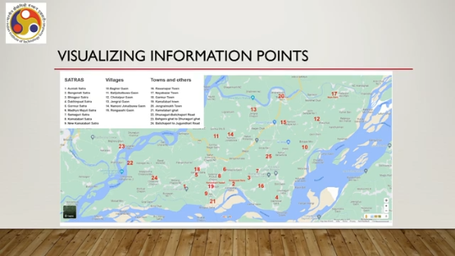
Then few villages, six villages, also captured two, captured the tangible and intangible heritage aspects of the tribal culture, and also we captured few towns and other places to capture both tangible and intangible heritage aspects of the mixed culture. Geographically, they are spread around the island as shown here. So, as you can see,
we consider this place to be in. So, we have given some labels, numerical labels starting from 1 to 24, and those labels, those labeled spots are spread around the island. Now, from here you can understand the expanse of information. So, this is the entire island capturing the cultural landscape of the entire island in terms of 24 spots which are spread which are spread around the island and we have to capture in each spot a good amount of information so that they represent the cultural heritage aspects of the whole island.
Now, in order to create that archive of the island in terms of these 24 spots, So, we have captured regular and 360-degree images and also videos to capture the indigenous architectural heritage of Satras and village life which are intangible heritage aspects as well. So, we have utilized images and videos, both regular images, 2D images, and 360-degree images and videos, to capture the tangible and intangible aspects of the heritage at those 24 spots. Also, we have created 3D models based on the captured images, of course, for recreation of the landscape, and partly this recreation also included ecological heritage preservation and also
We recreated the tangible heritage aspects in the form of architectural heritage using 3D models. Along with that, we have captured 2D drone shots to showcase the landscape and top view of the spots, places of the island. Drone views also were utilized to digitally recreate, digitally preserve, and recreate the unique flora and fauna of the island that is part of ecological heritage preservation aspect. Then we captured 2D videos to depict cultural or intangible heritage along with 360-degree videos. In addition to all of these images and 360-degree videos, images, 3D models, 2D drone shots, 2D videos, we also have created some textual descriptions of certain artifacts, objects, elements,
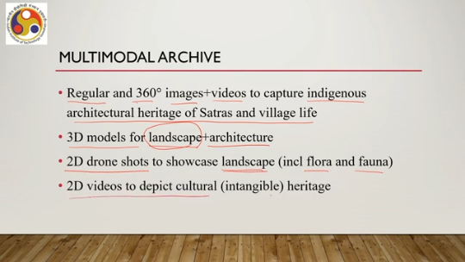
that are present on the island to capture more information about those, and so that is also part of the multimodal archive created to preserve the heritage aspects of the island. These are some of the statistics, some kind of things that we have captured. So, of course, we have captured much more than what the number shows here, but after going through The captured information, we have processed and kept those that are required, that are the minimum things required. And we can utilize this information to recreate more expansive virtual landscape.
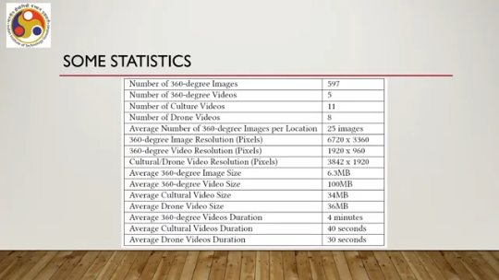
So, number of 360-degree images that we eventually used were about 600. 360-degree videos that we captured and utilized in our system, 5. 2D regular videos capturing intangible cultural aspects, 11. Drone videos, 8. Now, we said that there are 24 locations.
So, average number of 360-degree images captured per location, about 25. 360-degree image resolution, the kind of resolution that we have utilized is high definition, of course; you can see 6720 by 3360. Then drone 360-degree video resolution, 1920 by 960. The drone video utilized for cultural and ecological preservation. Again, very high resolution, 3842 by 1920. Average 360-degree image size is about 6.3 MB.
Average video size, 360-degree, 100 MB. Average 2D videos used to capture cultural aspects, intangible aspects, size of those, 34 MB. Drone video size average, 36 MB. 360-degree video duration on average, 4 minutes.
Cultural video duration. Cultural video means 2D videos captured to preserve or to capture the 2D videos recorded to capture the Cultural aspects, intangible aspects of the island, about 40 seconds, and finally, drone videos duration average duration 30 seconds. So, these are some of the statistics or we can say attributes associated with the multimodal archive that we have created to preserve the heritage information, which we can utilize to recreate a virtual tour of the Majuli River Island.
These are some of the example images, 360-degree images captured for the island. Just a sample of two places inside of Aunaiti Satra and Bahgor Ghat. Now, utilizing this information, so that is about the creation of the archive. Now, using that archival information, we recreated the island in the virtual space and created an immersive tour to explore the island. Now, the objective was an immersive interactive experience of the island's heritage, both tangible and intangible, as we have outlined earlier.
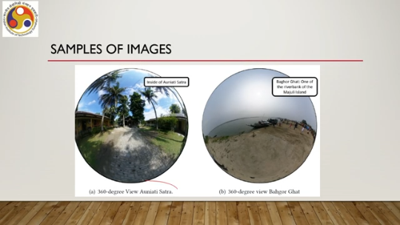
What are the key challenges in doing that? So, we are trying to build an interactive system to be used by people who may or may not have technical know-how that is We have already discussed this in the previous lecture: that is, we are trying to build something for lay persons and an interactive system. So, this is a classical problem of interactive system development. The challenge is how to build systems for such users. We have already
We got exposed to the interactive system development lifecycle. In the previous lecture, we can utilize that, but there will be challenges while adopting that for building the Majuli VR Tour. And in our subsequent discussions, we will see what those challenges are and how to overcome them. The key challenges are understanding the users, understanding their requirements and converting those to design ideas.
So, these three first we need to know who the users are, then we need to know what their requirements are and finally, those requirements we need to convert to design ideas which can be implemented. So, the final step is implementation from the design. So, these are the key challenges when we are trying to build the interactive Majuli virtual tour.
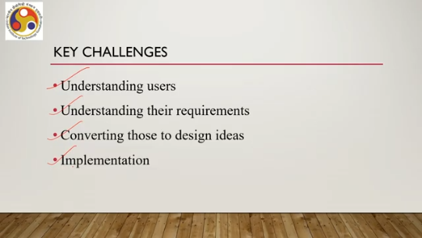
Also important is testing if the design meets user requirements. Now, here testing, if you recollect from our previous lecture, here testing means testing of usability rather than only code. Of course, code testing is part of it, but our main focus will be on usability testing. So, that is also another challenge: how to test the usability of Majuliv VR tour.
Then another challenge is we have to take into account the vast information, both tangible and intangible, as we have seen in the statistics. And we need to combine that to create an immersive tour that should be usable and covers the entire island, the vast geography. Now typically when we talk of virtual tours of a museum or other places, those are geographically small areas. Here we are trying to cover almost 427 square kilometers of area in the virtual tour which we captured in terms of these 24 spots.
Now, that is the challenge: how to let the user explore that vast geographical area, And at the same time experience the heritage that is recreated using the vast information that we have captured. It is quite likely that covering the entire island while experiencing the heritage may lead to cyber sickness because the size is huge. So the duration will be more, the interactivity will increase manifold if the user wants to explore the island in depth. Which may lead to cyber sickness.
So, the challenge is how to minimize cyber sickness here. So, that is one of the key challenges. So, now we are going to conclude this lecture by summarizing what we have covered. So, we introduced the case and in this part of the lecture we talked about the key concerns and challenges that needed to be resolved while trying to build and deploy such a system. Of course, in this lecture, we just covered the case as well as the challenges.
Now, how to resolve those challenges, we have not discussed here. That will be the subject matter of the subsequent few lectures, where we are going to talk about how to resolve those in terms of the stages that earlier we got introduced to while discussing the interactive system development lifecycle, how those stages, how that systematic life cycle based approach can help us overcome these key concerns, these challenges that we have just outlined in the context of building an immersive virtual tour of the Majuli River Island. So, next we are going to talk about how to develop the system taking into account the interactive system development life cycle stages to meet the challenges.
So, I hope you could understand the case and you could understand the challenges associated with building such a system for the digital preservation of the heritage of Majuli. In subsequent lectures, you will get to know how to actually put the idea into practice, how to put the theory into practice by going step by step on how those issues are resolved in the context of the Majuli Island Virtual Tour. So, looking forward to meeting you in the next lecture. Until then, thank you and goodbye.
Happy learning.

